Shay Walker

Box #: 613

Professor Sabal

Cairn University School of Business

CIS122 Essentials of Networking

Project #1

Project objective:

To learn how to properly create Ethernet cables from CAT5e cable and connectors (RJ 45) using the proper methods and equipment. It is important to know how to create these cables because you may face problems concerning length, functionality, and lifespan of Ethernet cables in your future career, or general use.

Equipment used:

|  |  |  |  |  |
| --- | --- | --- | --- | --- |
| Equipment Description | Vendor | Vendor Item # | Retail price | Actual price (if known) |
| CAT5e cable | Zones | 00146912 | $119.00 | N/A |
| RJ 45 connectors (qty50) | Zones | 00506365 | $8.58 | N/A |
| Crimper (CAT5/6 UTP) | Home Depot | 206304274 | $13.13 | N/A |
| Scissors | Walmart | 565618788 | $1.16 | N/A |
| Laptop (generic) | Newegg | 1TS-000D-01GJ6 | $584.00 | N/A |
| Switch | Zones | 03012187 | $429.98 | N/A |
|  |  |  |  |  |

Detailed list of software and operating platforms used, including version numbers and licensing requirements:

N/A

Network diagram:

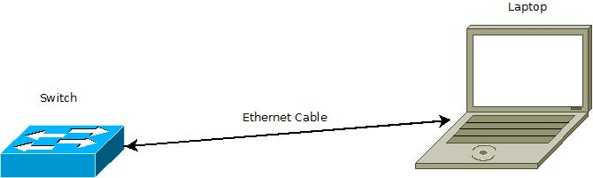

Configurations:

T568B wire configuration was used in this exercise. Therefore, the wires were ordered in the specific color orientation of White/Orange, Orange, White/Green, Blue, White/Blue, Green, White/Brown, Brown. Otherwise the configuration included an ethernet cable, with RJ45 connectors, that are inserted into a laptop port and a switch (see Dia diagram above).